*FROM THE GRILL*
**With your choice of Lettuce, Tomatoe, Mayo, Ketchup, Relish, Mustard,
Onions or pickles on any sandwich**

Philly Steak or Philly Chicken Sandwich
Your choice of Mushrooms, Peppers, Onions or Cheese……….............$5.49
Grilled Chicken Sandwich
Your choice of BBQ, Honey Mustard or Cajun Sauce……......................$4.99
Hamburger…………………………………………...…………………..................................$3.29
Turkey Burger…………………………………………………………..……………………….$3.29
Buffalo Burger (made with real Bison meat)………………………….…………….………..$3.99
10” Grilled Hotdog (Add Chili for $0.35)……………………………..…………….………....$2.79
Tuna Melt……………………………………………………………..……………….………...$3.89
Pastrami & Swiss Melt…………………………...…………………..…………………….…..$4.49
BBQ Pork Sandwich………………………………………………........................................$5.49
Corned Beef Rueben Melt………………………….............................………………….….$4.49
Triple-Decker Grilled Cheese………………………………………..………………....……..$2.49

*Make it a dinner, includes fries and coleslaw for just $1.00*

*SIDE ORDERS*
French Fries: Small…$1.49...Medium…$2.39…………………....Large…$3.89
Curley Fries: Small…$1.79…………………………………………Large…$2.99
Onion Rings: Small…$1.79…………………………………………Large…$2.99
HenHouse Potatoes: Small…$2.49………………………………………….Large…$3.99
Mashed Potatoes & Gravy: Small...$1.59…Medium..$1.89 Large..$2.39 X-Large…$2.99

Breaded & Fried Vegetables:
Choose from Mushrooms, Zucchini, Cauliflower or Broccoli & Cheese…………………...$3.99
Pizza Roll or Spinach Roll…………………………………………………….......……..…..…$1.39
6 Jalapeno Peppers…………………………………………………………………….….….…$3.99
6 Mozzarella Sticks with Marinara Sauce…………………………………………….….……$3.99
Fried Apple Pie……………………………………………………………………….…….…….$0.99

*HOMESTYLE SALADS*
ALL SALADS: $1.59/ ½ pound; $2.79/pound; single serving $0.70

Coleslaw Three Bean Salad Beets & Onions
Potato Salad Potato & Egg Salad Baked Beans
Macaroni Salad Macaroni & Chicken Salad

4 Deviled Eggs….$1.49 1 Kosher Pickle….$0.89
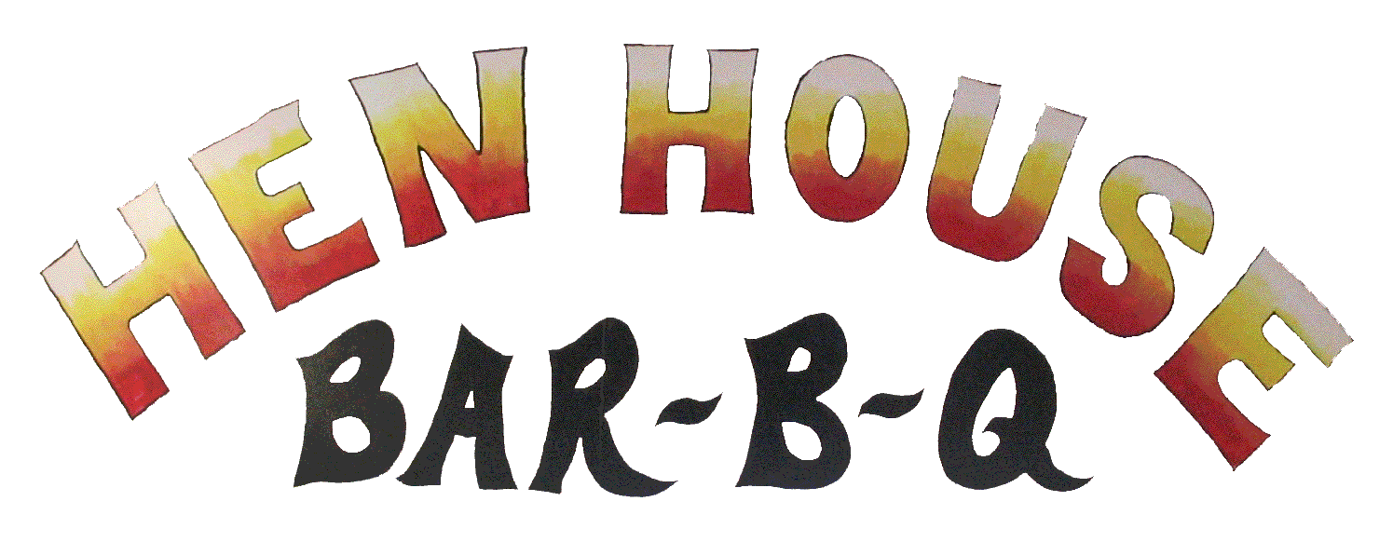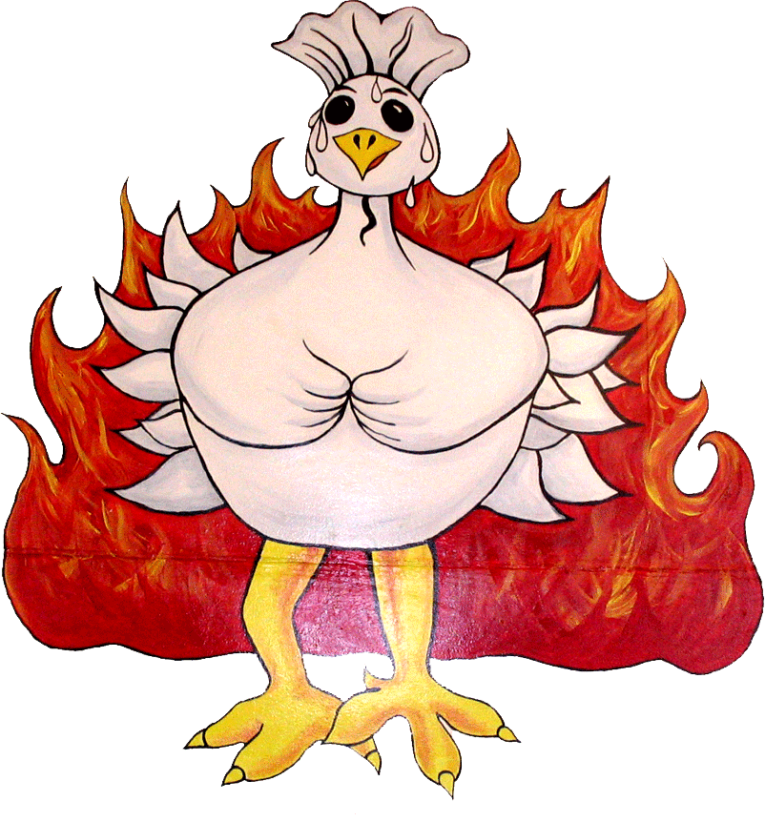
*Chicken* *Spare Ribs* *Seafood*
*Grill* *Hot Wings* & More

Ask to see our catering menu!!!

Open Tuesday through Sunday
10 A.M. until 9 P.M.

*CLOSED MONDAYS*

192 Main Street. Southington CT
Take Out- (860) 276-0798

www.henhousebbq.com
*SOUTHERN FRIED CHICKEN*
ALL DINNERS INCLUDE FRENCH FRIES, CLOESLAW & ROLL
(Substitute Onions Rings or Curley Fries for an extra $0.50)

DINNERS BY THE PIECE
#1 Chicken Nugget Dinner…….........….$6.29 4 Pieces……..….…$5.99
Chicken Nugget Only…………….………$4.99 8 Pieces…….….…$11.49
Chicken Sandwich Dinner……..…….…..$6.19 12 Pieces….….…...$16.69
Chicken Sandwich Only………………….$4.99 16 Pieces…….........$21.99
Chicken Parmesan Sandwich Dinner…..$6.19 20 Pieces……..…...$25.99
Chicken Parmesan Sandwich Only….…$4.99 24 Pieces……….…$32.99
*Your Choice of Lettuce, Tomato or Mayo* 28 Pieces……….…$35.99

FRIED CHICKEN DINNERS PARTY PACKS
#2 Breast & Wing……….……..…….….$5.69 #3 Breast , Leg & Thigh..$6.59
#2 DARK: Leg & Thigh……………..…..$4.99 #4 4 Breast……….……....$10.49
Four Chicken Wings…………..….…$5.69 #5 4 legs & 4 Thighs….…$10.49
#2 White: Two Chicken Breast……....$6.99 #6 8 Wings…….……........$6.99

FRIED CHICKEN & RIB COMBOS Pail of Southern Fried
#2 Dark Combo: Leg, Thigh & 2 Ribs..$8.59 Livers or Gizzards
#2 Combo: Breast, Wing & 2 Ribs…....$8.99 $3.99

*HEN HOUSE HOT WINGS*
Includes Blue Cheese and Carrots
Choose from 6 different sauces:
Mild, Hot, X-Hot, Honey BBQ, Spicy Honey BBQ & Caribbean

10 Piece Hot Wings……………………..$5.69 Buffalo Style Nugget Dinner…………..$6.49
16 Piece Hot Wings……………….…….$8.79 Buffalo Style Nugget Only…………..…$5.19
20 Piece Hot Wings………… ……….$10.99 Buffalo Chicken Sandwich Dinner……$6.49
30 Piece Hot Wings…………… …….$14.69 Buffalo Chicken Sandwich Only……...$4.99
50 Piece Hot Wings……………… ….$23.99 Your Choice of Lettuce, Tomato or Mayo

*CHILDRENS MENU*
All Dinners Include French Fries & your choice of Fruit Snacks,
Fried Apple Pie, Cookies or Pudding (Chocolate or Vanilla)

Chicken Sandwich…………..…………..$4.39 Hamburger……………....……...$3.29
Chicken Nuggets……………………..….$4.39 Grilled Cheese……………..…....$3.29
Clam Strips………………....…………….$4.39 Hot Dog………..……………..….$3.29

*BARBECUED CHICKEN & RIBS*
ALL DINNERS INCLUDE FRENCH FRIES, CLOESLAW & ROLL
(Substitute Onions Rings or Curley Fries for an extra $0.50)

DINNERS RIBS BY THE PIECE
#42 2 Piece Rib Dinner……..…..$5.29 1 Piece Rib……...…..…$1.85
#43 3 Piece Rib Dinner……..…..$6.59 3 piece Rib…………..…$5.49
#44 4 Piece Rib Dinner…………$8.19 5 Piece Rib……….……$8.79
#45 5 Piece Rib Dinner…………$9.49 8 PieceRib……………..$13.89
#46 One Whole Chicken Only…$7.29 10 Piece Rib………...…$17.29
#47 ½ BBQ Chicken Dinner……$5.99 12 Piece Rib…………...$19.99
#48 ½ BBQ Chicken Dinner 15 Piece Rib………...…$24.99
with 1 Rib……………………$7.69

*SEAFOOD MENU*
ALL DINNERS INCLUDE FRENCH FRIES, COLESLAW & ROLL
(Substitute Onions Rings or Curley Fries for an extra $0.50)

YOU’RE CHOICE OF LEMON, TARTAR SAUCE OR COCKTAIL SAUCE

DINNERS INDIVIDUAL ITEMS
#29 Flounder Sandwich Only……$3.79 Flounder Sandwich Dinner..$5.29
#30 Shrimp Dinner….……..…..….$6.59 Shrimp………………..………$5.00
#31 2 Piece Flounder Dinner….…$6.59 1 Piece Flounder….….……..$2.50
#32 Scallop Dinner………….…….$6.59 Scallops………………..……$5.00
#33 Stuffed Clam Dinner (3).…….$4.29 1 Stuffed Clam……………...$0.89
#34 Fresh Clam Strip Dinner…….$7.39 Fresh Clam Strips…..………$5.50

*MEAL DEALS*
#10: 8 Piece Chicken, #35: 5 Pieces of Flounder, #49: 1 Whole Chicken
Medium Fry, Medium Fry, Large Mashed
1 lb. any Salad 1 lb. any Salad Potatoes with
6 Dinner Rolls 6 Dinner Rolls Gravy on side &
$16.49 Includes Lemon & Tartar 6 Dinner Rolls
$16.49 $10.49

*INDIVIDUAL PIECES OF CHICKEN*
1 Breast……………$2.69 1 Thigh…………….$1.45
1 Leg…………….…$1.45 1 Wing……….…….$0.99
½ BBQ Chicken……$3.65

Dipping Sauces Include: Honey Mustad, Sweet & Sour,
BBQ, Ranch, Honey and Hot Sauce

